

Software Project

**Kacper Agatowski**

**N00212272**

Software Project

e.g. Develop an event ticketing application

Year 2 2022-23

DL836 BSc (Hons) in Creative Computing

Link to resources created as part of the project.

|  |  |
| --- | --- |
| GitHub | Link to your GitHub repository |
| Video | Link to your video file (MS Stream, YouTube) |

Table of Contents

1 Introduction 1

2 Business Concept 2

2.1 Business Idea 2

2.2 Business model 2

2.3 Market Research 2

2.4 Marketing/Advertising 2

2.5 Suppliers 2

2.6 Competitors 2

2.7 Employees 2

2.8 Environmental Impact 2

3 Requirements 3

3.1 Introduction 3

3.2 Requirements gathering 3

3.2.1 Similar applications 3

3.2.2 Interviews 3

3.3 Requirements modelling 3

3.3.1 Functional requirements 3

3.3.2 Non-functional requirements 3

3.3.3 Use Case Diagrams 4

3.4 Feasibility 4

4 Web application Design 6

4.1 Layout 6

4.2 Interaction 6

4.3 Colour schemes 6

4.4 Font choices 6

4.5 Wireframes 6

5 Database Design 7

5.1 Description 7

5.2 Business Reporting Requirements 7

5.3 Textual Representation of Data-Set 7

5.4 Business Rules 8

5.5 Entity Relationship Diagram 8

5.6 Tables 9

5.7 Database Dictionary 10

6 System Design/ Architecture Overview 11

6.1 Introduction 11

6.2 Model View Controller 11

6.3 User Authenticaion 11

6.4 Routing 11

6.5 Templating 11

7 Testing 12

7.1 Introduction 12

7.2 Functional Testing 12

7.2.1 Login/Registration 13

7.2.2 Navigation 13

7.2.3 Calculation 13

7.2.4 CRUD 13

7.2.5 Discussion of Functional Testing Results 14

7.3 User Testing 14

7.4 Conclusion 14

8 Project Management 15

8.1 Introduction 15

8.2 Project Phases 15

8.2.1 Requirements 15

8.2.2 Design 15

8.2.3 Implementation 15

8.2.4 Testing 15

8.3 SCRUM Methodology 15

8.4 Project Management Tools 16

8.4.1 Github Project 16

8.4.2 GitHub 16

9 Reflection 17

9.1 Your views on the project 17

9.2 How could the project could be developed further? 17

9.3 Assessment of your learning. 17

9.4 Completing a large software development project 17

9.5 Technical skills 17

9.6 Further competencies and skills 17

10 References 18

# Introduction

Overall aim

Application area

Technologies

PHP, MySQL, Bootstrap, CSS, Vanilla

Tools

IDE, phpMyAdmin, Miro

Project management

GitHub

Business Concept

Requirements

Design

Implementation

Testing

Reflection

# Business Concept

## Business Idea

This business idea came across me as my parents just had a child and were looking for baby clothes and accessories. The thing about buying baby clothes is that the baby would grow out of it and the parents are left with a lot of unused clothes and most importantly they are expensive. Generally, people would get clothes from people they know. Where my business idea is creating a site where customers could buy and sell from each other. This would save people money and allow people to get rid of these unused clothes for a price.

## Business model

As the business is mainly dependent on customers. The business would have to make money from a small percentage of each item sold. This wouldn’t affect the customer as the percentage would be small enough, they wouldn’t mind or notice within their profits.

Also, products sold straight from the business could be sold. The Business would have products made from sustainable material to keep the site environmentally friendly

## Market Research

The Market for this business would be for babies. Including clothes and accessories for babies which would come in all types of sizes. From my research the market for baby clothes and accessories is huge and there is a huge demand as the market wouldn’t depreciate in size, as there are babies being born and babies growing every minute. The target customers would be parents or future parents. These customers would use the service every couple months as their child would outgrow their clothes and they would be left with unwanted clothes and accessories for their child which is outgrown these products.

## Marketing/Advertising

Advertising wouldn’t be hard as there are many different locations parents would see. For example, Fliers in the school or speaking with the PTA for each school in the country. The only Con with this form of advertising is that it is not time efficient and it would take a long time to get the word around unless I had employees to advertise.

An easier way to advertise would be to place it on social medias such as TikTok, Facebook and Instagram. The Con of this would be that customers may flick past, and the message isn’t sent directly to them. The Pro is the that the message can be advertised with one click of a button.

## Suppliers

As I mentioned in my business idea, the customers supplying most of the market. As Parents would have unused clothes or clothes that their children have outgrown they would place it on the market for other customers to view and possibly buy. However, this would put all faith in customers to supply the market. So other suppliers could be EuroBaby.ie and M&M direct. The reasons I chose these two suppliers is as Euro Baby is a well-known Irish company and sell good quality accessories. M&M on the other hand is cheap and has a wide range of clothes.

## Competitors

After my research within this section, I didn’t find any similar ideas. However, I did find websites which sell baby accessories and clothes from a wide range however none with the selling feature and no clothes being second hand but coming straight from the manufacturer. DoneDeal and Facebook sites are similar sites where customers can buy and sell from each other are very successful businesses, however facebook you can’t filter certain sizes etc and donedeal is seen as an unsafe site when buying from a private seller which would scare customers.

## Employees

The business wouldn’t need many employees. However, it could have advertising employees to widen and make the service grow. I personally don’t think the customer should be sending the package straight to the other customer as it could invade the buyers privacy. Where the business could partner up or have a pickup/ delivery service. This would allow the buyers and sellers address stay private and secure.

## Environmental Impact

As the Customers would be reusing and recycling clothes and accessories it would be very environmentally friendly. However, if there is no customers there is no market so the business would have to supply their own clothes and accessories which wouldn’t be environmental friendly at all compared to the reselling, reusing and recycling.

# Requirements

## Introduction

This application main purpose would allow users to buy and sell their baby products. The application should be user friendly which would allow users to freely navigate and find what they are looking for. The selling point should be simple with some sort of verification that the item Is in fact a baby accessory or clothing.

## Requirements gathering

In this section I will be going through multiple business aspects. I do a competitor analysis and find the pros and cons of two similar application. I then interviewed two people who would be seen as my target audience, this was to give me more insight on what users will want to see within my application.

### Similar applications

DoneDeal is one of two similar applications to my application I am creating. Using an extension called FullPageGo I captured the full page of the baby’s section from DoneDeal.

DoneDeal is a trading site where people can sell and buy any item for a price. DoneDeal sells a wide variety of products, these products can either come from a private seller or a company. DoneDeal would make money from people placing ads which vary in price.

DoneDeal has many positives and very few negatives which made it very successful and Irelands largest Marketplace.

**PROS**

1. The layout is very basic and easy to read as they had their card components on the right which people have posted and on the left the filters.
2. Their filter allows users to navigate freely throughout the website and find what they are looking for.
3. Filtering through location allows users not to travel far to collect their items.
4. If the user can’t find the item they are looking for they can place a wanted ad to show other users they are looking for a specific product.
5. Users have the option to buy from a private or public seller. This allows them to buy products which aren’t second hand and come from a legitimate business.
6. The Sign up is simple and users to have full access to the site once they’re a member.

It was very hard to find negatives on a site which is very successful.

**CONS**

1. The marketplace covers plenty of products and doesn’t focus on one thing in general.
2. Private sellers may be verified but their products cannot be verified.
3. The transport of a product and transaction is left to the responsibility of the to the users where DoneDeal are not responsible for anything.
4. This way of selling wouldn’t be environmental friendly as the buyer would have to collect the product which could be on the other side of Ireland. Buyers would have to drive there.

Facebook Marketplace is the second similar application to mine. Facebook Marketplace is another online marketplace where users use their Facebook account to have access to this feature. Users can buy or sell products across the country. Facebook would make money through fees of 5% of items which are above 8 euro and only 40c which are under 8 euro, however these fees are for shipment which allows the users to have their product shipped.

**Pros**

1. The layout is the same as DoneDeal which makes it user friendly as the layout is the same in every other site.
2. Filters like “condition” is very important as it allows buyers to understand the condition of the product.
3. As the marketplace is connect to the users Facebook, buyers can have a look at the persons profile to get an understanding who they are buying from.
4. Facebook can manage transport with a fee for transportation from one customer to another.

There aren’t many pros about this marketplace in my opinion apart from the fact it relates to all your Facebook apps.

**Cons**

1. The filters are very broad, and you can’t narrow down your search unless you use the search bar which still doesn’t show exactly what the user is looking for.
2. Products are not verified, and anyone can create a Facebook profile which has any email address.
3. The Facebook marketplace for baby products seems unused and not many people would buy baby products from here.

### Interviews

I conducted interviews with each one of my parents as they would be my target audience. My parents have after had another child which is now six months old and even before my baby brother was born I could see them stressing about baby products and complaining about the prices. I asked them the same questions which I have listed below.

Hi, I will be conducting a few questions for my Software project in school, and I will be asking questions about online marketplaces.

1. Would have used any online marketplace to find clothes and accessories for your baby? If yes, ask which online marketplace. If no, ask how they would gather products.
2. What were the apps best features when looking for products?
3. What were the apps worst features when looking for products?
4. If you were to use an app like this again what would you like to have included?

Thank you for your time and cooperation.

Interview 1 -> Greg (no recording)

1. Yes, I mainly would have used DoneDeal.
2. Their best feature would have probably been the wanted filter as it was really easy to find what we wanted. For example, we were looking for a specific Philips Avent sterilizer and a new one was around 120 euro and we put up a wanted ad where we got a reply within, I think two weeks and the person sold it for 30 euro which was second hand but never used.
3. The worst feature would be privacy, I’ve had my account since 2016 but know a friend of mine who got texts from a random number and believes its from donedeal when he posted his car for sale.
4. I don’t know probably have a safer policy to not allow people to contact your private number but your account possibly.

Interview 2 -> Kamila (not recorded)

1. Yes, eBay and Facebook.
2. eBay was good for looking for everything and was easy to find but most things I found were from the UK. Facebook was hard to find things as it was difficult to find a specific thing.
3. eBay had good features, but Facebook was just difficult to find specific things. They would have needed more filters and their search just didn’t work, when I was looking for a specific crib.
4. I would love to see all the filter options like eBay has but possibly some sort of trading feature as well.

Greg’s feedback was good and gave me some good feedback but Kamila’s feedback seemed a bit too bias towards eBay but both allowed me to understand what they would like to see in my application.

## Requirements modelling

I went through the functional and nonfunctional requirements i expect to fulfil at the end of creating my project. I then created a case diagram to help me visualize how the business will work.

### Functional requirements

1. Placing Products on the database through the app.
2. View page when clicking on a product.
3. Filter
4. Search
5. Gamification when buying and selling.
6. Contacting users to one another (buyer and seller)

### Non-functional requirements

The application should be user friendly. I will keep the layout the same to not confuse the user from where everything is. Keeping the filter on the left and the components on the right with a search on the top of the screen.

I will track performance by keeping a record of error rates. I will carry out test where I will bring in users to test the performance of my app.

I will manage security when coming to the different roles when deleting and editing users posts. Giving each component a uuid to not allow anyone to view items and access other users’ profiles. I will try to keep users registering information hidden as much as possible from other users.

### Use Case Diagrams

## Feasibility

The two technologies I plan to use are Laravel and Bootstrap as I am familiar with both programs. According Cloudways.com it is said that bootstrap and Laravel are compatible with each other. I will also use xampp to use mySQL to be allowed to store data.I will install Breeze for an authentication method as it is compatible. I will use bootstrap for css and html. From other research VueJS is the best compatible framework with Laravel, however I am unfamiliar with VueJS.

# Web application Design

In this section I will discuss the design aspect of my website. I explored layouts, interactions, investigated colour schemes and font choices on an application called Miro. I then created wireframes using an application called Figma to help me visualize my online marketplace.

## Layout

After comparing my competitors’ websites, I noticed that each of their layouts were the same with a filter on the left side of the screen and their card components on the right. I decided to keep the overall layout the same as it won’t confuse users and allow them to move fluidly through the application. Using Bootstrap, I will be able to achieve my goal to recreate the basic layout fundamentals by using their cards and responsive forms.

## Interaction

The user will be able to interact with the application in many ways. Each page will a navigation bar at the top of the screen to change the views between discover, profile, notifications etc. The discover/ main page would have filters on the left for the users to interact and narrow down their search for their product they are looking for. The search bar would allow them to filter for specific items.

Bootstrap framework has built in features with validation. This would mean fully responsive form will be seen when trying to buy a product which their details will be stored within the database including their role.

## Colour schemes

I used Miro and Figma to allow me to view different colour palettes and allow me to choose the most eye catching one. Each of the competitor applications were standard black and white with a tertiary colour of red on done deal and blue on Facebook. I created four different color palettes on my figma and used the most eye-catching ones in my wireframes to help me visualize. The two colors that were the most eye catching was the thistle light blue and international Klein blue. I plan to use the thistle color on the nav bar and filter and use the darker blue on strokes of my cards with black text and grey cards.PowerPoint

## Font choices

I explored three different font pairs using fontpair.co to see which fonts are compatible with each other. The three font pairs I explored were Work Sans & Merriweather , Oswald & Source Sans Pro and DM Serif Display & DM Sans. I chose serifs to use as my headings and sans for normal paragraph text as it would be easier to read. I explored these fonts in Figma seeing the text in bold and different sizes.

The font pair I decided to choose which I thought was suitable for my site was Oswald for Headings and Source Sans Pro for normal paragraph text.

## Wireframes

The user would open the application and view the main page first which shows all the products available and filter. I created iterations to explore new layouts and components.

Here are two iterations of my nav bar.





Here are three iterations of my components.

I placed my chosen component as I thought it was the most visible and easy to read for the user.

I then added my chosen color to help me visualize the application.

Once the user clicks on anything on the page it will bring them to the login/ sign up page will be a basic Laravel registration page including some other details. However, if they are logged in already it will bring them straight to the view page.

This is the first iteration of my view page however I preferred the layout of the second iteration.

I used the smaller components to place them into the view page which shows other items the seller is selling. From this page the user can either add to cart and continue shopping or go straight to the sell which would be a simple payment form where a confirmation is sent out after and the item is deleted from the database.

Link to Figma : <https://www.figma.com/file/GaclqrPmwmgsfJLx65f7xA/Software-Porject-kacper?node-id=4%3A109&t=jXqiKpO76s9BmuDj-1>

# Database Design

## Description

A company has a website that sells video games for different consoles. They would need a database for all their games and order places. For each order place, they would need games bought, total price, date of the order, and how long it will take to deliver. The database needs to keep track of all games that are being sold. Customers will have to input their information when registering an account. Customers will also have to input their card details when making a payment for their order.

## Business Reporting Requirements

Substitute in here the information the users of your application will want to be able to view.

1. Organisers need to be able to create, read, update, and delete: festivals, stages, shows, performers, and genres.
2. Users will need to be able to find all festivals ordered by their start date.
3. Users may want to find a festival by a specific start date.
4. Users need to find all festivals using a list of genres.
5. Users need to find the stage for a specific show.
6. Users need to find the shows using the performer's name.
7. Performers may need to find the list of festival contacts.
8. Users need to find festivals by location and the location needs to be displayed on a Google Map
9. Users may need to find festivals by city
10. Users need to find stages within a festival by the stage’s location
11. Organisers need to display a list of employees that are assigned to a specific festival

## Textual Representation of Dataset

Substitute in here the tables for your database

**FESTIVAL** (title, description, latitude, longitude, city, start_date, end_date, image_id)

**PERFORMER** (title, description, contact_email, contact_phone, image_id)

**GENRE** (title, description)

**IMAGE** (id, filename)

**SHOW** (date, start_time, end_time, performer_id, stage_id)

**STAGE** (title, description, location, festival_id, image_id)

**GENRE**_**PERFORMER** (id, genre_id, performer_id)

**EMPLOYEE** (name, phone, email)

**FESTIVAL_EMPLOYEE** (employee_id, festival_id, role)

## Business Rules

Substitute in here the business rules for your database

• A **Festival** has many **Stages**.

• A **Stage** belongs to one **Festival**.

• A **Stage** hosts many **Shows**.

• A **Show** is performed on one **Stage**.

• A **Performer** can perform in many **Shows**.

• A **Show** is performed by one **Performer**.

• A **Performer** can have many **Genres**.

• A **Genre** can belong to many **Performers**.

• A **Performer** can have a single **Image**.

• A **Festival** can have a single **Image**.

• A **Stage** can have a single **Image**.

• An **Image** can be associated with a **Performer**, **Festival**, or **Stage**

• A **Festival** can have many **Employees** associated with it

• An **Employee** can be assigned to one **Festival** at a time

## Entity Relationship Diagram

Substitute in here your ERD from draw.io

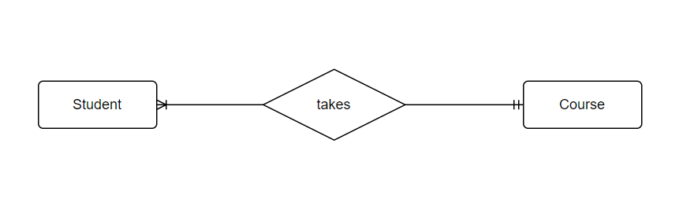

## Tables

Substitute in here your tables and the relationships between tables from draw.io in the format you used in DBMS with Mohammed.

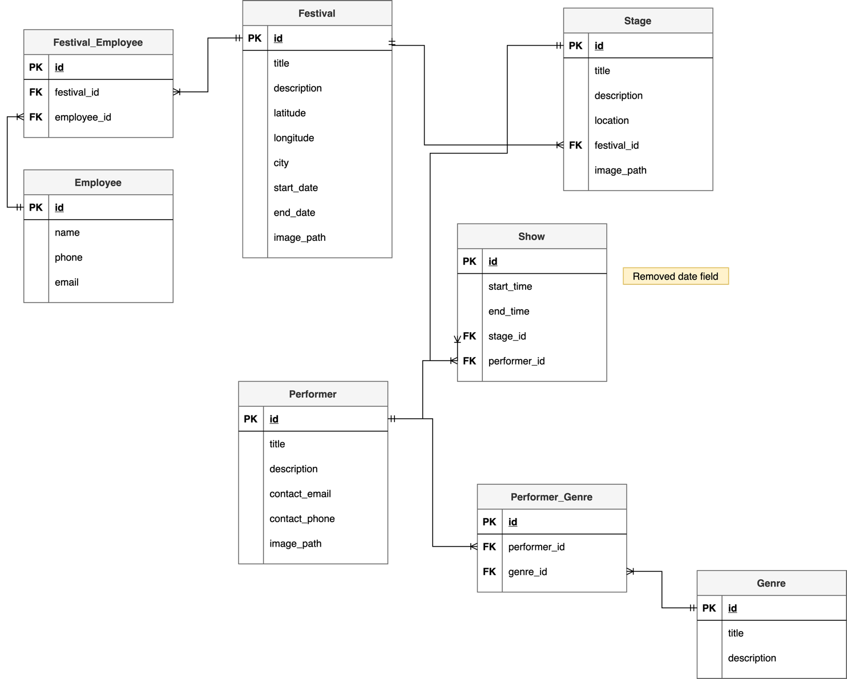

## Database Dictionary

|  |  |  |  |  |  |  |
| --- | --- | --- | --- | --- | --- | --- |
| Table | Attribute | Datatype | Range | Required | PK/FK | FK Ref Table |
|  |  |  |  |  |  |  |
|  |  |  |  |  |  |  |
|  |  |  |  |  |  |  |
|  |  |  |  |  |  |  |
|  |  |  |  |  |  |  |

# System Design/ Architecture Overview

* 1. Introduction

This section will describe the internal functionality of the web framework that you have chosen for the implementation. Add further sections if required by the specification of your web application

* 1. Model View Controller

Explain the follows a model-view-controller design pattern and how it is implemented in your web application.

* 1. User Authentication

Explain how user authentication is implemented in the web application framework.

* 1. Routing

Describe the routes that were defined in the web application

* 1. Templating

Describe the templating engine and how it was used to configure/ style the web application.

Add a sequence diagram in this section and other diagrams that illustrate the architecture clearly.

# Testing

* 1. Introduction

This chapter describes the testing that has been undertaken for the application. This chapter is presented in two sections:

1. Functional Testing
2. User Testing

Functional testing is a type of software testing whereby the system is tested against the functional requirements. The app is tested by looking to see if the actual output for a given input corresponds with the expected output. The tests should be based on the requirements for the app. The results of functional testing can indicate if a piece of software is functional and working, but not if the software is easy to use.

User testing looks to see if a piece of software is easy and intuitive for the user.

* 1. Functional Testing

This section describes the functional tests which were carried out on the app. These functional tests can be categorised as: (whatever is relevant to your app)

* Login/Registration
* Navigation
* Calculation
* CRUD

Functional testing generally uses a Black Box Testing technique which means that the internal logic of the system being tested is not of interest to the tester. The tester is only interested in whether the actual output agrees with the expected output.

* + 1. Login/Registration

|  |  |  |  |  |  |
| --- | --- | --- | --- | --- | --- |
| Test No | Description of test case | Input | Expected Output | Actual Output | Comment |
|  |  |  |  |  |  |
|  |  |  |  |  |  |
|  |  |  |  |  |  |

* + 1. Navigation

|  |  |  |  |  |  |
| --- | --- | --- | --- | --- | --- |
| Test No | Description of test case | Input | Expected Output | Actual Output | Comment |
|  |  |  |  |  |  |
|  |  |  |  |  |  |
|  |  |  |  |  |  |

* + 1. Calculation

|  |  |  |  |  |  |
| --- | --- | --- | --- | --- | --- |
| Test No | Description of test case | Input | Expected Output | Actual Output | Comment |
|  |  |  |  |  |  |
|  |  |  |  |  |  |
|  |  |  |  |  |  |

* + 1. CRUD

|  |  |  |  |  |  |
| --- | --- | --- | --- | --- | --- |
| Test No | Description of test case | Input | Expected Output | Actual Output | Comment |
|  |  |  |  |  |  |
|  |  |  |  |  |  |
|  |  |  |  |  |  |

### Discussion of Functional Testing Results

Describe the results from the tests. Address any functionality where unexpected behavior could not be debugged.

* 1. User Testing
  2. Conclusion

Discussion of test results.

# Project Management

## Introduction

This chapter describes how the project was managed. It shows the phases of the project, going from the project idea through the requirements gathering, the specification for the project, the design, implementation and testing phases for the project. It also discusses GitHub as a tool which assists in project management.

## Project Phases

In this section, describe each of the following project phases. Explain any issues which arose for each of the phases.

### Requirements

### Design

### Implementation

### Testing

Include a Gantt chart

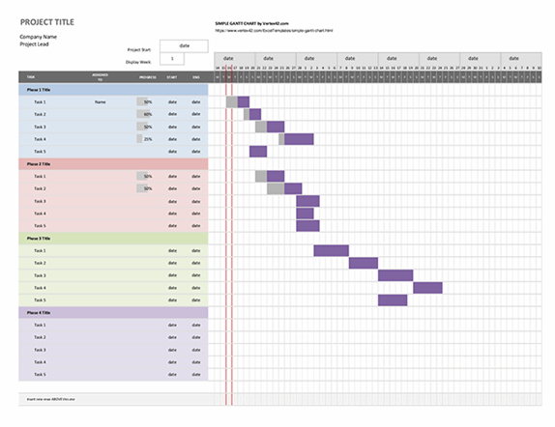

## SCRUM Methodology (optional)

Sprints

## Project Management Tools

### GitHub Project

Description

Include screen shots

How it worked in practice

### GitHub

Description

How it is used

How it worked in practice

# Reflection

## Your views on the project

Describe how you feel the project went from your perspective.

## How could the project be developed further?

## Assessment of your learning.

Critically assess your learning. List what skills and competencies you have learned developed in this Continuous Assessment.

List which part of the project would need further development and itemize where you feel you have not satisfactorily completed the continuous assessment.

## Completing a large software development project

Describe what you have learnt from the project, from the point of view of completing a large software development project.

## Technical skills

Describe what you have learnt from the project, from a technical skills viewpoint.

## Further competencies and skills

Describe any extra competencies and skills that would help you with your development in the workplace.

# References

Add a list of references that you used to complete the project.

The Department of Technology and Psychology in IADT uses APA 7th referencing style.

Use alphabetical order for your references.

This site gives details about how to cite websites using APA:

https://www.wikihow.com/Cite-a-Website-in-APA

The following is a useful site for creating citations for APA for websites.

<http://www.citationmachine.net/apa/cite-a-website>

You can also use the Referencing tab within Microsoft Word to enter reference information manually. Word then creates an APA style reference.